Note: This report is provided as an example for you to use when preparing your lab report. However, remember that you must state your results in your own words, and copy/pasting from this report would be plagiarism.

Final Assessment Sample Report

Study: Gut microbiome analysis of animals within an Australian river catchment
Student name:
Student ID:

Background

Fecal contamination has been a central focus in microbiology due to its health implications. Traditionally, culture based approaches have been used that rely on the growth of fecal indicator bacteria. This poses a challenge since these indicators are rarely identified, and if identified are not linked to their original source. This is a big oversight as identification of sources is key for developing management and health response strategies.
The gut microbiome represents a unique marker distinguishing different species of organisms (cite). Prior work has shown that the microorganisms inhabiting each host species are directly selected for based on host, diet, health status or other (cite). This suggests that certain organisms can serve as indicators of fecal contamination and could be used as a method for fecal source tracking (i.e. the ability to identify the original source of the fecal contamination). Since microbiome analysis is a culture independent approach, this allows a much wider group of indicators to be used far surpassing the available culturable indicators. However, in order to use this approach a basic understanding of the sources and distinct microbiomes potentially contributing fecal contamination is required.
In natural systems this can be difficult due to the large number of organisms that can inhabit a catchment. In Australia, the diverse fauna creates a challenge for tracking fecal sources, many of whom have never been studied. In this study we compare the gut microbiomes of different host species found in Australia.

INSERT DESCRIPTION OF STUDY.
Include:
- Main goal, specific questions being asked, hypotheses and experimental design
- Total number of samples
- Treatments/variables to be compared
- Number of sequences per sample
- Total number of OTUs identified.
- Any additional relevant information about your study or preliminary descriptive results

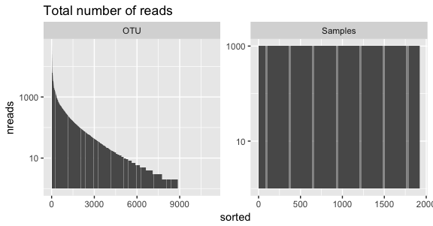
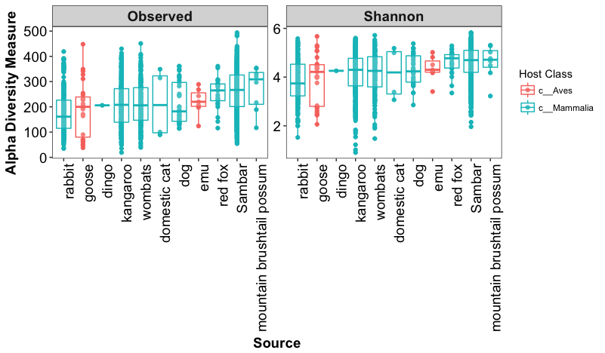
Methods and results for alpha diversity measurements
Figure 1 Read and sample summary after rarefication.
Figure 2 Comparison of alpha diversity [richness and Shannon] across different hosts.
The original dataset was rarefied to 1000 reads per sample prior to analysis (Fig 1). Results show differences in alpha diversity (Fig 2, Kruskal-Wallis test for both Richness and Shannon p < 0.01) across host species. Richness values ranged between 19-494 OTUs, with a median of 232, while Shannon diversity ranged between 0.9-5.8 and a median of 4.5. A Tukey's HSD (honest significant difference) test was used to determine which hosts had significantly different alpha diversities (Tables 1-2). Generally, sambar and red fox samples were identified as being the most diverse with an X fold increase in richness compared to Y and Z. However these differences were not conserved across entire host classes wit no significant differences in alpha diversity between birds and mammals.

Methods and results for beta diversity measurements
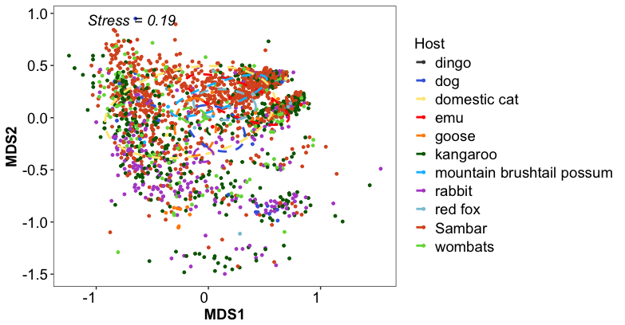
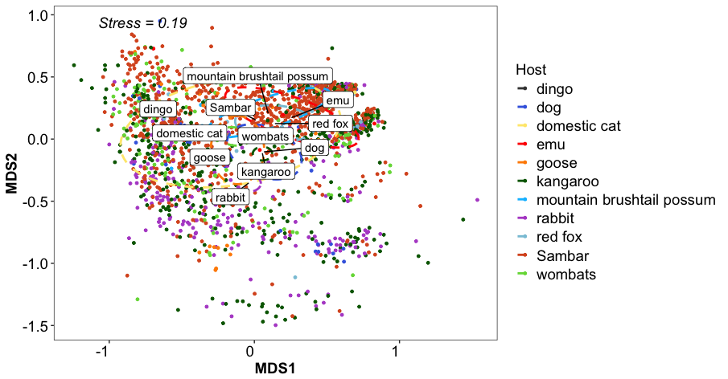
A Bray-Curtis distance matrix was used to determine differences in beta diversity and sample clustering was visualized using an NMDS plot (Fig 3). Significant differences in community composition where seen between different hosts (ANOSIM R = 0.15, p =0.001; ADONIS Signif= 0.03, p=0.001), but effects were small. Samples clustered primarily by species, but a broad overlap across multiple hosts was observed. This shared overlap suggested recurring species of microbes found across multiple hosts.
Figure 3 Non-metric multidimensional scaling (NMDS) plot using a Bray–Curtis dissimilarity matrix showing differences in community composition and color coded for source host of microbiome.

Methods and results for taxonomic comparisons
To compare community composition across hosts, relative abundance of OTUs were compared at the phylum (Fig 4) and genus level (Fig 5). Variance in phylum level relative abundance was observed, specially for dingos, but no strong and clear pattern emerged. The major phyla detected included: LIST MAJOR PHYLA AND PROVIDE MEAN +/-SD. More marked changes were observed when abundant OTUs (top 50) were summarized at the genus level. Differences in abundance of : LIST significantly different organisms, indicate how variable they are by comparing the lowest to the highest abundance.

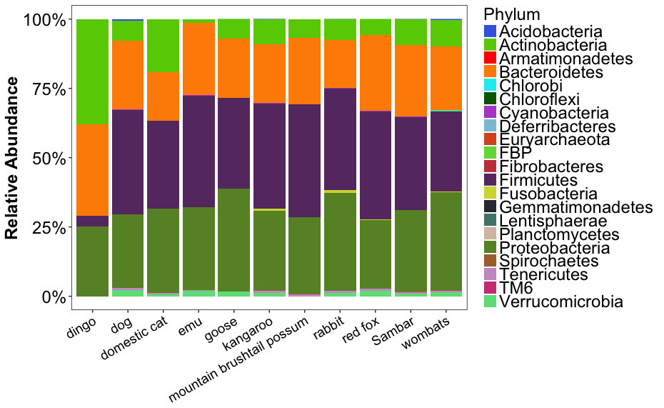
Figure 4 Relative abundance of phyla contributing more than 1% of reads across hosts.

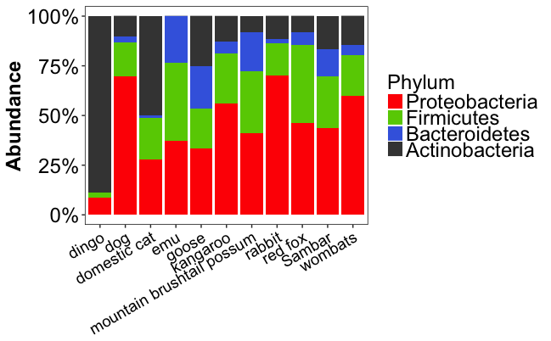
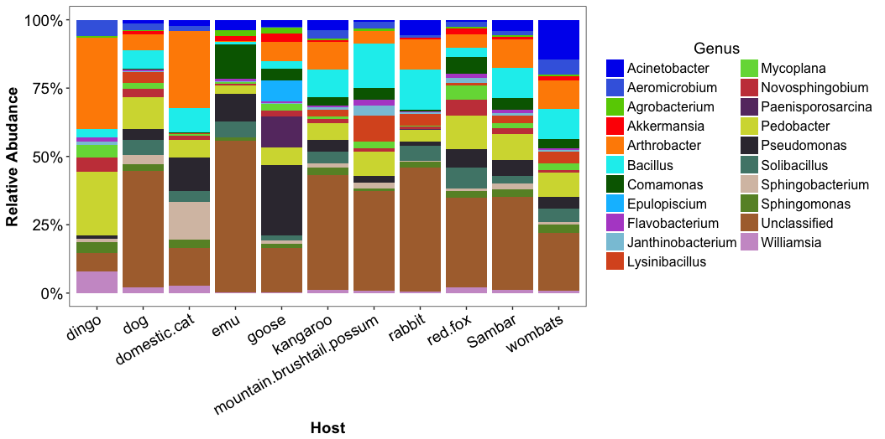
To determine what OTUs were contributing to the changes in community composition a SIMPER analysis was performed with a dataset containing only abundant organisms (mean relative abundance > .05%). Average dissimilarities between hosts are summarized in Table 3. Due to the number of variables being compared data is only shown for OTUs identified as important in differentiating rabbit and emu microbiomes. In order to show difference between hosts the full dataset was subsetted by OTUs contributing to the top 25% of the variance when microbiomes where compared. These two hosts represented the most different communities in the dataset. Results at the phylum level (Figure 6):DESCRIBE RESULTS USING QUANTITATIVE LANGUAGE AND PROVIDE STATS IF NEEDED. In order to identify key genera linked to hosts, OTUs contributing more than 10% of the variance were identified and abundance was plotted at the genus level. Most reads where associated with unclassified OTUs, with a single identified genera (Comamonas) being the only other listed taxa. While relative abudance of these two genera was not highly variable, absolute abundance was, with significantly more reads associated to emu than to other hosts (Fig 8). When each genera was analysed separately (Figure 9) , clear differences in all three genera were observed. Emu’s were associated with higher numbers of an Unclassified Ruminococcacea and Comamonas, while being depleted in the Unclassified Oxalobacteraceae.
Figure 6 Phylum level changes in microbiomes across hosts based on OTUs contributing 25% of the variance in a SIMPER analysis comparing rabbit and emu microbiomes.
Figure 5 Relative abundance of genera represented amongst the 50 most abundant OTUs across all hosts. Reads plotted represent 39% of all reads
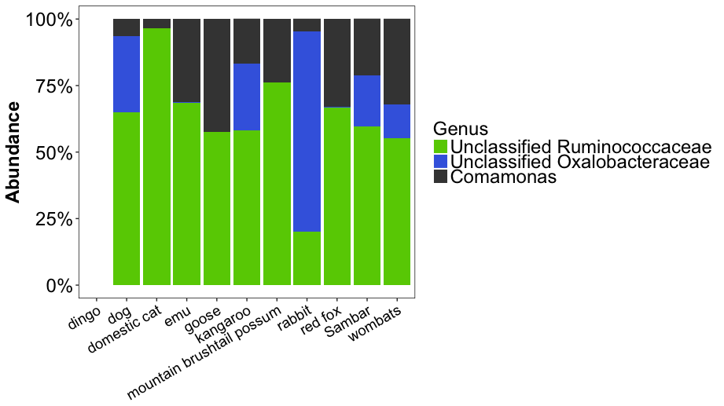
Figure 7 Genus level changes in microbiomes across hosts based on OTUs contributing top 10% of the variance in a SIMPER analysis comparing rabbit and emu microbiomes.

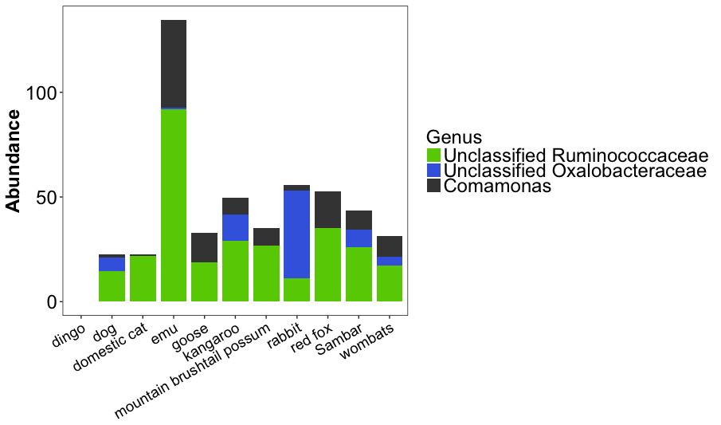
Figure 8 Absolute abundance of OTUs contributing 10% of variance.

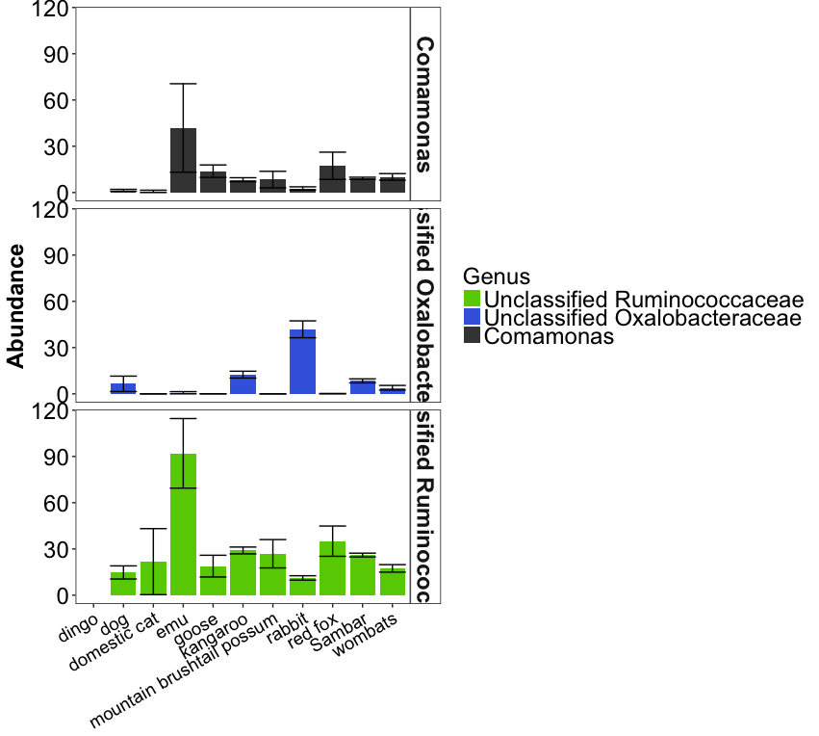
Figure 9 Absolute abundance
Discussion and synthesis

In this section you should summarize your findings and provide some interpretation (what does it mean?). You will need to link your findings to prior work/knowledge by citing previous research to support your interpretation or provide context to your study. Things to consider:
- Have these observations been reported previously?
- Are your observations reinforcing known facts, or do they contradict them? If the latter, what could have happened to cause this?
- Did you confirm or reject your hypotheses? Have you answered the question you set out to answer?
- What do your results mean? What is the main ‘take home’ message?
- Where would you go next (next logical step in the research).

Supplementary Tables and Figures

Table 1 Tukey multiple comparisons of means based on richness between hosts
 | diff | lwr | upr | p adj
Sambar-rabbit | 68.89 | 43.70 | 94.08 | 0.00
Sambar-kangaroo | 44.01 | 23.54 | 64.48 | 0.00
wombats-Sambar | -43.42 | -73.38 | -13.46 | 0.00
Sambar-goose | 83.80 | 13.97 | 153.63 | 0.01
red fox-rabbit | 90.55 | 14.26 | 166.84 | 0.01
red fox-goose | 105.46 | 5.16 | 205.77 | 0.03
rabbit-kangaroo | -24.88 | -52.66 | 2.90 | 0.13
red fox-kangaroo | 65.67 | -9.19 | 140.54 | 0.15
wombats-red fox | -65.08 | -143.07 | 12.91 | 0.21
wombats-rabbit | 25.47 | -9.88 | 60.83 | 0.42
rabbit-dog | -38.18 | -105.18 | 28.82 | 0.76
goose-dog | -53.09 | -146.52 | 40.35 | 0.76
kangaroo-goose | 39.79 | -31.01 | 110.59 | 0.77
wombats-goose | 40.38 | -33.72 | 114.49 | 0.81
red fox-dog | 52.38 | -44.17 | 148.92 | 0.81
mountain brushtail possum-goose | 71.71 | -72.21 | 215.64 | 0.88
red fox-domestic cat | 96.00 | -97.10 | 289.10 | 0.88
Sambar-dog | 30.71 | -33.60 | 95.02 | 0.91
rabbit-mountain brushtail possum | -56.80 | -185.15 | 71.54 | 0.94
Sambar-domestic cat | 74.34 | -104.83 | 253.50 | 0.96
goose-emu | -60.25 | -211.90 | 91.40 | 0.97
rabbit-emu | -45.34 | -182.29 | 91.61 | 0.99
red fox-dingo | 114.50 | -250.42 | 479.42 | 1.00
red fox-emu | 45.21 | -108.37 | 198.80 | 1.00
Sambar-red fox | -21.66 | -95.61 | 52.28 | 1.00
mountain brushtail possum-domestic cat | 62.25 | -156.70 | 281.20 | 1.00
Sambar-dingo | 92.84 | -264.91 | 450.58 | 1.00
mountain brushtail possum-kangaroo | 31.92 | -95.58 | 159.43 | 1.00
wombats-mountain brushtail possum | -31.33 | -160.70 | 98.04 | 1.00
red fox-mountain brushtail possum | 33.75 | -112.22 | 179.72 | 1.00
domestic cat-dog | -43.63 | -233.24 | 145.99 | 1.00
emu-domestic cat | 50.79 | -173.32 | 274.89 | 1.00
mountain brushtail possum-dingo | 80.75 | -298.48 | 459.98 | 1.00
rabbit-goose | 14.91 | -57.40 | 87.22 | 1.00
kangaroo-dog | -13.30 | -78.67 | 52.07 | 1.00
wombats-dog | -12.70 | -81.64 | 56.23 | 1.00
emu-dingo | 69.29 | -312.95 | 451.52 | 1.00
Sambar-emu | 23.55 | -112.11 | 159.21 | 1.00
dog-dingo | 62.13 | -300.96 | 425.21 | 1.00
wombats-domestic cat | 30.92 | -149.96 | 211.80 | 1.00
kangaroo-domestic cat | 30.33 | -149.22 | 209.87 | 1.00
kangaroo-emu | -20.46 | -156.62 | 115.70 | 1.00
wombats-emu | -19.87 | -157.78 | 118.04 | 1.00
wombats-dingo | 49.42 | -309.18 | 408.02 | 1.00
kangaroo-dingo | 48.83 | -309.11 | 406.76 | 1.00
mountain brushtail possum-dog | 18.62 | -122.71 | 159.96 | 1.00
Sambar-mountain brushtail possum | 12.09 | -114.88 | 139.05 | 1.00
rabbit-dingo | 23.95 | -334.29 | 382.18 | 1.00
mountain brushtail possum-emu | 11.46 | -173.58 | 196.51 | 1.00
goose-domestic cat | -9.46 | -201.02 | 182.09 | 1.00
emu-dog | 7.16 | -142.03 | 156.35 | 1.00
domestic cat-dingo | 18.50 | -381.25 | 418.25 | 1.00
rabbit-domestic cat | 5.45 | -174.70 | 185.59 | 1.00
goose-dingo | 9.04 | -355.07 | 373.14 | 1.00
wombats-kangaroo | 0.59 | -31.57 | 32.76 | 1.00

Table 2 Tukey multiple comparisons of means based on Shannon diversity between hosts
 | diff | lwr | upr | p adj
Sambar-rabbit | 0.67 | 0.47 | 0.86 | 0.00
Sambar-kangaroo | 0.41 | 0.25 | 0.57 | 0.00
wombats-Sambar | -0.35 | -0.58 | -0.12 | 0.00
red fox-rabbit | 0.83 | 0.24 | 1.43 | 0.00
rabbit-kangaroo | -0.25 | -0.47 | -0.04 | 0.01
wombats-rabbit | 0.32 | 0.04 | 0.59 | 0.01
Sambar-goose | 0.61 | 0.07 | 1.16 | 0.01
red fox-goose | 0.78 | 0.00 | 1.56 | 0.05
red fox-kangaroo | 0.58 | 0.00 | 1.16 | 0.05
rabbit-dog | -0.48 | -1.00 | 0.04 | 0.10
wombats-red fox | -0.52 | -1.12 | 0.09 | 0.18
goose-dog | -0.43 | -1.16 | 0.29 | 0.71
rabbit-emu | -0.56 | -1.62 | 0.50 | 0.84
rabbit-mountain brushtail possum | -0.52 | -1.52 | 0.48 | 0.84
red fox-domestic cat | 0.76 | -0.74 | 2.26 | 0.87
red fox-dog | 0.35 | -0.40 | 1.10 | 0.92
wombats-goose | 0.27 | -0.31 | 0.84 | 0.92
kangaroo-dog | -0.23 | -0.74 | 0.28 | 0.93
goose-emu | -0.51 | -1.69 | 0.67 | 0.95
Sambar-domestic cat | 0.59 | -0.80 | 1.98 | 0.96
mountain brushtail possum-goose | 0.47 | -0.65 | 1.59 | 0.96
kangaroo-goose | 0.20 | -0.35 | 0.75 | 0.98
Sambar-dog | 0.18 | -0.32 | 0.68 | 0.98
wombats-dog | -0.17 | -0.70 | 0.37 | 1.00
Sambar-red fox | -0.17 | -0.74 | 0.41 | 1.00
kangaroo-emu | -0.31 | -1.36 | 0.75 | 1.00
emu-domestic cat | 0.49 | -1.25 | 2.23 | 1.00
domestic cat-dog | -0.41 | -1.88 | 1.06 | 1.00
red fox-mountain brushtail possum | 0.31 | -0.82 | 1.45 | 1.00
mountain brushtail possum-kangaroo | 0.27 | -0.72 | 1.26 | 1.00
mountain brushtail possum-domestic cat | 0.45 | -1.25 | 2.15 | 1.00
wombats-kangaroo | 0.06 | -0.19 | 0.31 | 1.00
red fox-dingo | 0.67 | -2.16 | 3.51 | 1.00
red fox-emu | 0.27 | -0.92 | 1.47 | 1.00
wombats-emu | -0.24 | -1.31 | 0.83 | 1.00
wombats-mountain brushtail possum | -0.20 | -1.21 | 0.80 | 1.00
Sambar-dingo | 0.51 | -2.27 | 3.28 | 1.00
wombats-domestic cat | 0.24 | -1.16 | 1.65 | 1.00
Sambar-mountain brushtail possum | 0.14 | -0.84 | 1.13 | 1.00
emu-dingo | 0.40 | -2.57 | 3.37 | 1.00
kangaroo-domestic cat | 0.18 | -1.22 | 1.57 | 1.00
mountain brushtail possum-dingo | 0.36 | -2.58 | 3.31 | 1.00
dog-dingo | 0.32 | -2.50 | 3.14 | 1.00
Sambar-emu | 0.11 | -0.95 | 1.16 | 1.00
rabbit-goose | -0.05 | -0.61 | 0.51 | 1.00
emu-dog | 0.08 | -1.08 | 1.24 | 1.00
rabbit-dingo | -0.16 | -2.94 | 2.62 | 1.00
wombats-dingo | 0.16 | -2.63 | 2.94 | 1.00
rabbit-domestic cat | -0.07 | -1.47 | 1.32 | 1.00
goose-dingo | -0.11 | -2.93 | 2.72 | 1.00
mountain brushtail possum-dog | 0.04 | -1.06 | 1.14 | 1.00
kangaroo-dingo | 0.09 | -2.69 | 2.87 | 1.00
domestic cat-dingo | -0.08 | -3.19 | 3.02 | 1.00
goose-domestic cat | -0.02 | -1.51 | 1.46 | 1.00
mountain brushtail possum-emu | -0.04 | -1.48 | 1.40 | 1.00

Table 3 Pairwise commparison of hosts and observed dissimilarity in community composition based on SIMPER analysis of abundant (mean relative abundance >0.05) OTUs
 | Dissimilarity
domestic.cat_dingo | 76%
Sambar_dingo | 87%
wombats_dingo | 87%
red.fox_dingo | 87%
mountain.brushtail.possum_dingo | 87%
dog_dingo | 88%
Sambar_mountain.brushtail.possum | 88%
emu_red.fox | 88%
goose_dingo | 89%
kangaroo_dingo | 89%
Sambar_domestic.cat | 90%
emu_goose | 90%
domestic.cat_mountain.brushtail.possum | 90%
red.fox_mountain.brushtail.possum | 90%
rabbit_dingo | 90%
Sambar_red.fox | 90%
dog_domestic.cat | 91%
emu_mountain.brushtail.possum | 91%
kangaroo_mountain.brushtail.possum | 91%
kangaroo_domestic.cat | 91%
red.fox_domestic.cat | 91%
Sambar_emu | 91%
dog_red.fox | 91%
dog_mountain.brushtail.possum | 91%
kangaroo_red.fox | 91%
Sambar_goose | 91%
wombats_domestic.cat | 91%
wombats_mountain.brushtail.possum | 91%
goose_red.fox | 92%
Sambar_kangaroo | 92%
goose_mountain.brushtail.possum | 92%
Sambar_wombats | 92%
wombats_red.fox | 92%
kangaroo_emu | 92%
Sambar_dog | 92%
kangaroo_dog | 92%
goose_domestic.cat | 92%
rabbit_domestic.cat | 92%
rabbit_dog | 93%
kangaroo_rabbit | 93%
wombats_emu | 93%
wombats_goose | 93%
kangaroo_wombats | 93%
emu_domestic.cat | 93%
Sambar_rabbit | 93%
wombats_dog | 93%
rabbit_mountain.brushtail.possum | 94%
rabbit_wombats | 94%
kangaroo_goose | 94%
rabbit_red.fox | 94%
emu_dog | 94%
goose_dog | 95%
emu_dingo | 95%
rabbit_goose | 96%
rabbit_emu | 96%

